Chateau Walk Homeowners Association
Neighborhood News April 2024

Association Annual Assessment Due on May 1 It is that time of year when the annual assessment is due. The amount due for 2023 is $590.00 and is due May 1. A late fee of 10% or $59.00 will be assessed if the annual assessment is not received by May 10. Please make payment at https://homeside.cincwebaxis.com/. The credit card fee is 3.5% plus $2.95. An e-check payment has a service fee of $2.95. Save yourself the fees and have your bank make payment from your bill pay service or mail in a check. Mail payment to Chateau Walk Homeowners Association, Inc., c/o Homeside Properties, Inc., PO Box 907, Commerce, GA 30529-0907. If we do not receive the association dues and the late fee by June 1, we assess a rebilling fee of $50.00. Why wait? Please make your payment now.

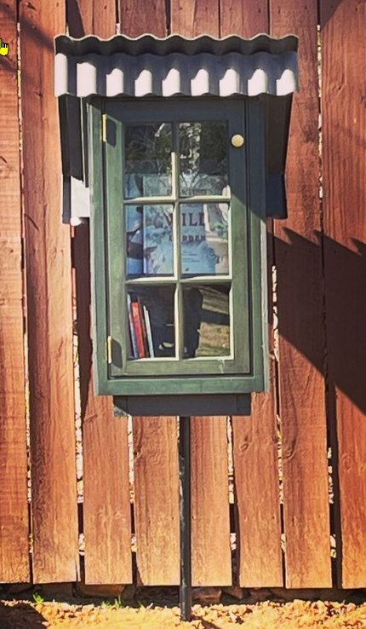
New Addition Little Library Our thanks to Elizabeth, Peter and Sterling Merritt for the installation of our Chateau Walk Little Library. Located next to the playground, the little library has wonderful books to borrow, enjoy and then return when done. You can add books too!

Pool Opening 2023 The pool opening date is Saturday, May 6. While the pool maintenance company has removed the safety cover to start the pool preparation, the pool is NOT OPEN. It has not been inspected for occupancy by the county health department. Strong chemicals in use ensure the pool is sanitized and ready for inspection. Entering the pool is hazardous.

Pool Work Day 2023 We need a few volunteers to come out on Saturday, April 29 at 1:00 pm (Rain Date is Sunday, April 30 at 1:00 pm) to ensure everything is open and ready for another Chateau Walk pool season. We need to check the equipment, clean the bathrooms, update the furniture layout, and any other task that is needed.

Thanks for being great neighbors,

Chateau Walk HOA Board
Merideth Hawks, Keitra Osborne, and Gary LaRue

